Importing an example TAK ML Model
Example TAK ML Models can be found here:
https://tak.gov/documentation/resources/example-models
Copy the zip file(s) to your Android Device’s SD Card. After installing and activating the plugin, you may import the TAK ML Models.

Use the ATAK Import Tool to import the Zip File:
1. Open Hamburger Menu and find the Import Tool
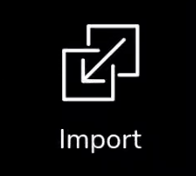
2. Select “Local SD”
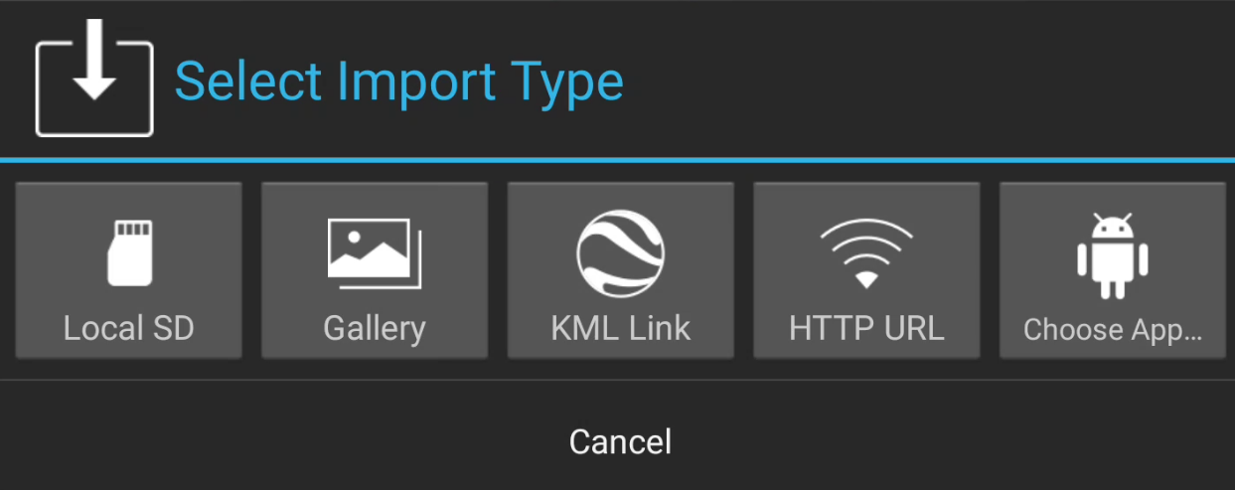
3. Finally locate your TAK ML Model Zip file. It may take up to several seconds, but a notification stating the model has been imported should appear

The model is now imported and can be used by the plugin.

Importing your own TAK ML Model
To use TAK ML, TAK ML Models must be defined. A TAK ML Model is a wrapper that includes the trained ML model and accessory files. The format is the following:
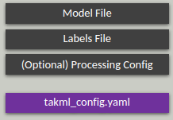
Creating a TAK ML Model Zip file is straightforward:
- Assure that the Generic Image Recognition Plugin is installed and loaded.
- Create an empty folder and create a takml_config.yaml file. Note, it must have this name. This Yaml file is a pointer to all the related files. It’s structure is as follows:
friendlyName: [friendly name for your TAK ML Model]
modelType: [Model Type, e.g. IMAGE_CLASSIFICATION, OBJECT_DETECTION, GENERIC_RECOGNITION, or LINEAR_REGRESSION]
modelName: [name of your trained model file]
labelsName: [if applicable (e.g. Object Detection or Classification) name of your class labels file, if applicable]
processingConfig: [if applicable (e.g. Pytorch Object Detection), name of your Processing Config, which provides specific info on how to process the model]
- Add your model file
- Add your labels file, if applicable (e.g. not Linear Regression). This is a line-separated list of classes. For example:
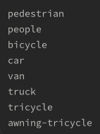
- If applicable, add your Processing Config. Currently, this is only applicable to Pytorch Object Detection. For example:
Please see the ”TAK ML Pytorch - Object Detection with Yolov5 Developer Guide” for more information.
- Zip up the file and copy to your Android device
- Use the ATAK Import Tool to import the Zip File:
  - Open Hamburger Menu and find the Import Tool
  - Select “Local SD”
  - Finally locate your TAK ML Model Zip file
  - It may take up to several seconds, but a notification stating the model has been imported should appear
  - The model is now copied to /sdcard/takml and imported into your TAK ML MLA application.

